

## TRIBHUVAN UNIVERSITY

**INSTITUTE OF SCIENCE AND TECHNOLOGY**

**Central Campus of Technology**

A Report Proposal On

### Smart Water Management: Digital Scheduling and Reservoir Optimization System for Dharan

**Submitted by**

**Rijan Rai (BIT 355/077)**

**Arun Khatri (BIT 341/077)**

**Arpan Shrestha (BIT 340/077)**

**Submitted to**

**Central Department of Computer Science and Information Technology**

**September 12, 2024**

|  |  |
| --- | --- |
| **Contents** |  |
| **Contents** | **i** |
| **List of Figures** | **ii** |
| **List of Tables** | **ii** |
| **1 Introduction** . . . . . . . . . . . . . . . . . . . . . . . . . . . . . . . . . . . | 1 |
| **2 Problem Statement** . . . . . . . . . . . . . . . . . . . . . . . . . . . . . . . . | 3 |
| **3 Objectives** . . . . . . . . . . . . . . . . . . . . . . . . . . . . . . . . . . . . . | 3 |
| **4 Limitations** . . . . . . . . . . . . . . . . . . . . . . . . . . . . . . . . . . . . | 4 |
| **5 Methodologies** . . . . . . . . . . . . . . . . . . . . . . . . . . . . . . . . . . | 4 |
| **5.1 Requirement Identification** . . . . . . . . . . . . . . . . . . . . . . . | 4 |
| **5.1.1 Literature Review** . . . . . . . . . . . . . . . . . . . . . . . | 4 |
| **5.1.2 Requirement Analysis** . . . . . . . . . . . . . . . . . . . . | 6 |
| **5.2 Feasibility Study** . . . . . . . . . . . . . . . . . . . . . . . . . . . . . | 7 |
| **5.2.1 Technical** . . . . . . . . . . . . . . . . . . . . . . . . . . . . | 7 |
| **5.2.2 Operational** . . . . . . . . . . . . . . . . . . . . . . . . . . | 7 |
| **5.2.3 Economic** . . . . . . . . . . . . . . . . . . . . . . . . . . . | 8 |
| **5.2.4 Schedule** . . . . . . . . . . . . . . . . . . . . . . . . . . . . | 8 |
| **5.3 High-Level Design of System** . . . . . . . . . . . . . . . . . . . . . . | 8 |
| **6 Expected Output** . . . . . . . . . . . . . . . . . . . . . . . . . . . . . . . . . | 12 |
| **References** | **13** |

**List of Figures**

### Population statitics of Dharan 2

### Gantt chart 8

### Flowchart for the System 10

### Use Case Diagram of Water Distribution System 11

**List of Tables**

### 1 Climate and weather data of Dharan 2

## 1 Introduction

In 21st century, urban water supply has become one of the most pressing issues, driven by various factors such as increasing population, changing lifestyle, economic growth and development. The United Nations World Water Development Report from 2018 reported that by 2050, almost 6 billion people will experience a shortage of clean water. This is due to the rising demand for water, declining water resources, and growing water pollution, which are all driven by rapid population growth and economic expansion [5]. With the rapid population growth in major cities around the world, meeting the increasing demand for water has become a significant challenge.

According to the Department of Water Supply and Sewerage Management (DWSSM), only 51.69% of the population have piped water coverage while 48.31% rely on non-piped locally and privately managed systems such as private tube wells (DWSSM 2019) [1].

In the context of Nepal, the main cities, Dharan, Dhulikhel, and Kathmandu, have been facing the water crisis. According to a report preview by O’Neill, the urban population in Nepal reached its highest share of 21.9% in 2023, showing a 2.33% increase compared to the previous year [2].

Dharan is situated on the foothills of the Mahabharat range with mostly flat ground but includes some steep areas. The city relies on two main water sources: surface water and groundwater. However, the demand for water is extremely high, leaving hundreds of households with irregular water supplies or forcing them to wait days for small amounts of water from their taps. The Dharan Water Supply Management Board oversees the city’s water distribution. Key factors contributing to water insecurity in Dharan sub-metropolitan include rapid population growth, climate change, limited water sources, steep terrain, over-extraction, technical leaks and political challenges.

In Dharan, water supply heavily relies on ground water as surface water may not be available all the time. Over the past decade, Dharan has been facing the water crisis, particularly during the dry seasons. Almost all households in Dharan have a piped water supply directly into their homes.

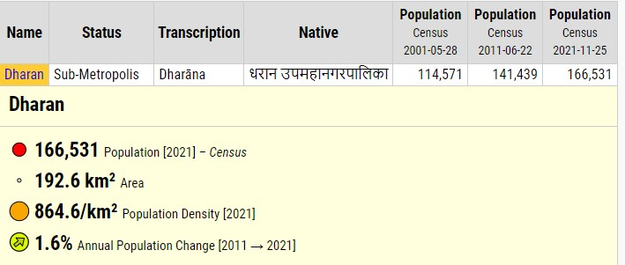

Figure 4.1: **Population statitics of Dharan**

**Source**: Central Bureau of Statistics Nepal (web).

In Dharan, the average water shortage months is 5.51 months. During the dry season, 49% water is less available compared to other months [3]. To meet the growing demand for water, it is essential to optimize its distribution, ensuring that all households receive an adequate supply according to their needs. By improving water allocation, we can help ensure a more equitable and sustainable supply across the city.

**Table 1: Climate and weather data of Dharan**

**Source:** Department of Meteorology and Hydrology

|  |  |  |  |  |  |  |  |  |  |  |  |  |
| --- | --- | --- | --- | --- | --- | --- | --- | --- | --- | --- | --- | --- |
| Climate Data for Dharan(1991-2020) | | | | | | | | | | | | |
| Month | Jan | Feb | Mar | Apr | May | Jun | Jul | Aug | Sep | Oct | Nov | Dec |
| Mean daily maximum  (in celsius) | 22.8 | 26.0 | 30.4 | 32.8 | 32.7 | 32.4 | 31.9 | 32.3 | 31.9 | 31.0 | 28.4 | 25.0 |
| Daily mean  (in celsius) | 17.0 | 20.2 | 24.2 | 27.1 | 27.7 | 28.3 | 28.5 | 28.5 | 27.8 | 26.0 | 22.7 | 19.2 |
| Mean daily minimum  (in celsius) | 11.2 | 14.3 | 17.9 | 21.3 | 22.7 | 24.1 | 24.6 | 24.6 | 23.7 | 20.9 | 16.9 | 13.3 |
| Average precipitation | 10.4 | 14.2 | 29.9 | 71.5 | 162.3 | 317.8 | 461.0 | 261.0 | 344.5 | 121. | 12.7 | 3.9 |

## 2 Problem Statement

Dharan is home to thousands of people. Being one of the most populated cities in Nepal, the challenge of providing sufficient water to the public has been a major problem in Dharan, especially during the dry season. On average, 20 million liters per day (MLD) are collected from both sources during each season. However, limited water availability combined with high demand has led to a significant water supply crisis. The current demand is approximately 30 MLD, but only 20 MLD is supplied, leaving a substantial deficit. This shortfall can only be addressed through large-scale infrastructure projects, such as sourcing water from the Koshi or Tamor rivers. Despite various efforts by local authorities and the Nepal Water Supply Corporation to address the water shortage in Dharan, the city continues to struggle with ensuring fair and consistent water distribution. The Dharan Water Supply Management Board (DWSMB) currently lacks a digital system to monitor, predict, and manage water levels and distribution in real-time. With limited water resources, rapidly growing demand, and inadequate supply, households often experience irregular or insufficient water access. This lack of efficient resource management, coupled with the absence of real-time data, has exacerbated water insecurity across the city. To address these issues, there is a critical need for a software solution that can provide accurate, real-time insights into water levels and optimize the distribution of available water to meet the needs of all residents effectively.

## Objectives

The main objective of the system we have designed is to equally supply/distribute the available water to all the ares or wards in the Dharan sub-Metropolitan city. The system provides a timely schedule, which lets the client or the public know when the water will be available in their area. Besides it some of the objectives of our proposed sytem are mentioned below

* 1. To provide an admin dashboard with real-time insights into current reservoir water levels and enable scheduling accordingly.
  2. To develop a mobile app that informs consumers about the water supply schedule.
  3. To ensure equitable water distribution across all wards.

## Limitations

Although significant effort has gone into preparing this research report, there are certain limitations that have impacted the study. Some of these are outlined below:

* 1. **Absence of IoT Devices, sensors or SCADA Systems**: The project does not incorporate Internet of Things (IoT) devices, sensors, Supervisory Control and Data Acquisition (SCADA) systems, or other technological instruments that can measure and transmit real-time water levels. The software is designed based on manually entered data rather than automated, real-time inputs from water tanks or distribution points.
  2. **Dependence on Assumed and Provided Data**: The timeframes for water distribution are also determined based on the population and demand assumptions, which may vary from actual consumption patterns and the water distribution logic is based on estimates rather than real-time consumption data. Additionally, the incoming and outgoing water flow data are based on historical records or estimates provided by the local water supply board, which may not always reflect real-time conditions.

## Methodologies

### Requirement Identification

#### Literature Review

* + - * **Sustainable WASH for all:** SUSWA is a human rights progressive bilateral project building on and continuing the long-term WASH sector cooperation of the Government of Finland and the Government of Nepal [4]. Sustainable WASH for all, SUSWA, is a bilateral human rights progressive Water, Sanitation, and Hygiene project funded by the Government of Nepal (GoN) and Government of Finland (GoF), as well as the European Union [4].
        + **Impact Statement:** The SUSWA project aims to enhance well-being and foster inclusive communities by promoting sustainable WASH (Water, Sanitation, and Hygiene) services and behaviors while strengthening local governments’ capacity to ensure equal WASH rights for everyone.
        + **Outcome Statement:** The project seeks to improve equitable access to safe drinking water, sanitation services, and hygiene practices, with a particular focus on the needs of women, girls, and vulnerable groups, supported by the municipalities involved.
        + **Sensor Dashboard Tank Status Overview:** SUSWA is implementing sensor dash- boards to enable municipalities to remotely monitor the functionality of water sys tems and determine the necessary technical or financial support. These sensors, utilizing ultrasonic technology, measure water levels in tanks and transmit data via the local GSM network. At regular intervals, they automatically report the water level in the tanks, which is then displayed live on a web-based interactive dashboard in both volume and percentage.
        + The dashboard, accessible publicly through the provided link, offers detailed in - sights, including the number of monitored tanks, their locations, capacities, current water levels, and usage trends. Additionally, the dashboard features an Open Street Map with RWT (Remote Water Tank) location points, color-coded according to hourly data updates.
        + The limitation of the SUSWA system is that it serves as a collective platform for multiple small municipalities with a broad focus on water, sanitation, and hygiene. As a result, it requires substantial funding for its development and implementation. In contrast, our system is designed to be more cost-effective, with a primary focus on optimizing water distribution. This targeted approach allows for significant cost savings while ensuring efficient and equitable water allocation.
      * **Small Town Water Supply and Sanitation Projects-I, Lekhnath Water Supply:** This project aimed to provide high standards of water supply services to about 240,000 people in about 29 small towns. The Lekhnath Small Town Water Supply Project, known as Lekhnath Khanepani, is one of the eight pilot projects proposed in the first phase of STWSSSP implemented by DWSS. It focuses on improving Water Supply Management with an Innovative System. In the town of Lekhnath in western Nepal, a GeoViewer asset management system has been installed, allowing the Water Users Committee to effectively manage and monitor their resources, plan maintenance and repairs, and keep track of asset performance in real-time.
        + The Lekhnath utility meter-readers visited nearly 16,000 customers and geo-positioned every meter, including the meter account number. This allows the asset management system to be linked to the utility’s billing system. The asset management system has drastically cut the time it takes to address payment, water quality, pipe leakage, and meter issues.
        + The Asian Development Bank (ADB) and the Government of Nepal are working together to supply water and sanitation services to small towns in Nepal. The asset management system has been financed by the High-Level Technology Fund, which brings in innovative and digital technologies into ADB projects. A cloud-based SCADA system (Supervisory Control and Data Acquisition) has also been installed to monitor tank levels.
        + Another feature of GeoViewer is the Customer App, allowing customers to report issues from their smartphones, such as a pipe leak, burst, or meter fault, with the accurate location and the option to upload a photo.
        + The Lekhnath system enhances asset management but does not focus on ensuring equi-table distribution of limited water resources, especially during periods of scarcity. Our project aims to optimize water distribution across different areas of Dharan, ensuring that wards receive water proportionally based on consumption needs, which is crucial forresource-limited regions.

#### Requirement Analysis

* Functional Requirements

1. Admin Dashboard
   1. Water level monitoring
   2. Incoming and outgoing water flow
   3. Prediction of how long the water lasts
   4. Scheduling water timetable
2. Water timetable for customer

* Non-Functional Requirements:

1. User-friendly interface
2. Reliability

### Feasibility Study

#### Technical

Following technologies have been chosen for the project, each selected based on the team's familiarity and technical competence. With our team’s current skills , we can ensure that we can develop the system within the project timeline.

1. **Laravel** - for the backend development of the system.
2. **MySQL** - As a database.
3. **Android SDK** - For developing the mobile version of the proposed system.
4. **Github** - For version control and managing the application.
5. **VS Code** - As an IDE (Integrated Development Environment).
6. **LaTeX** - For preparing the documentation and reports.

#### Operational

There is no digital system used by the Water Supply Board of Dharan to technically address the problem. So, with the help of this software, it will provide more easy way to the Water Supply Board of Dharan to gather real-time statistics to efficiently distribute the water. Also, the people in Dharan can easily use the mobile app for viewing the water schedule.

#### Economic

No major cost has occurred since we made it ourselves. Since this system will be used by the Water Supply Board of Dharan, by signing the terms with Dharan Sub Metropolitan City, we can hand over the system to them.

#### Schedule

The project is expected to last for 18 weeks, starting from the 3rd week of Shrawan and ending in the last of Mangshir.

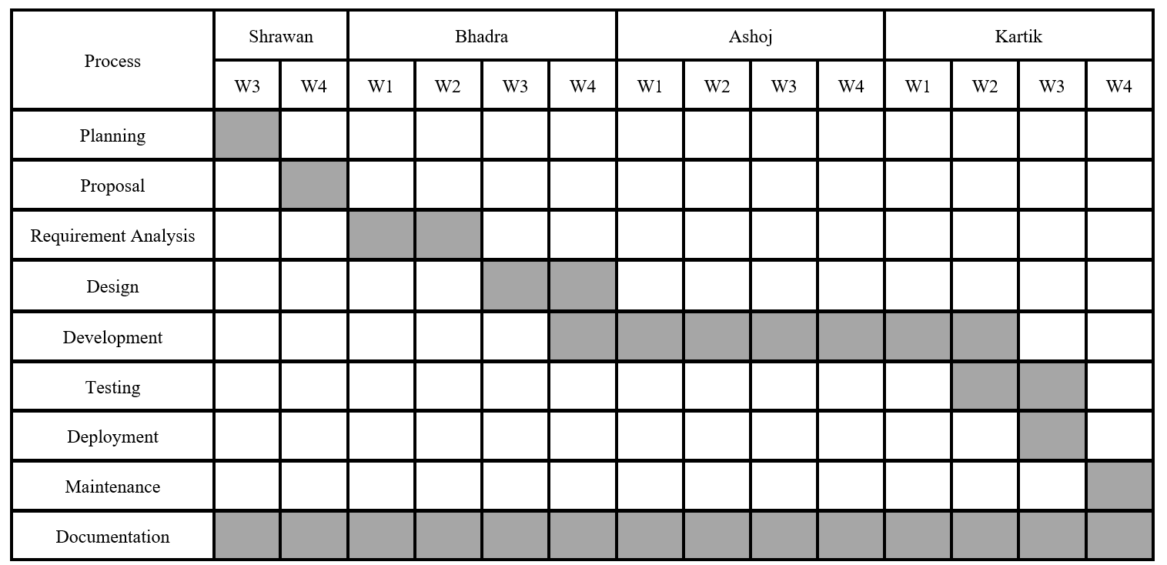

**Figure 2: Gantt chart**

### High-Level Design of System

**Design Approach:** We will initially follow the Waterfall model, a linear and sequential methodology, but remain open to adopting new models in the future as needed based on environmental changes.

**System Architecture:**

1. **Presentation Layer**
   1. Admin Panel (Web View): The admin panel will allow the administrator to monitor and administer the water levels in various tanks, schedule water supply to different areas, and view usage reports.
   2. Mobile App (API Integration): The mobile app will be integrated using RESTful APIs provided by Laravel, allowing users/clients to track water supply routines from the system.
2. **Business Logic**

Defines how the system should function to meet certain objectives.

* 1. Controller: water level monitoring controller, water supply/distribution controller

1. **Database**
   1. MySQL: The relational database model MySQL has been used for this system to store all the necessary data that the system is intended to use.

**Algorithm**:

We utilized a priority queue approach in the algorithm, which operates on the First-In-First-Out (FIFO) principle. However, only the areas with higher priority are placed in the queue, ensuring that those with greater need are served first.

#### Flowcharts:

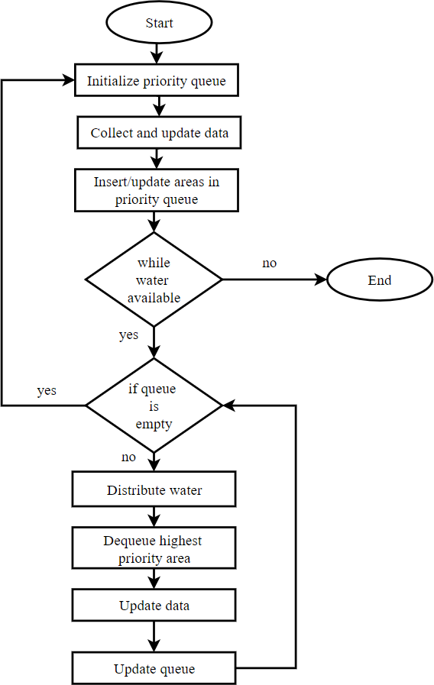

**Figure 3: Flowchart for the System**

**Use Case Diagram**

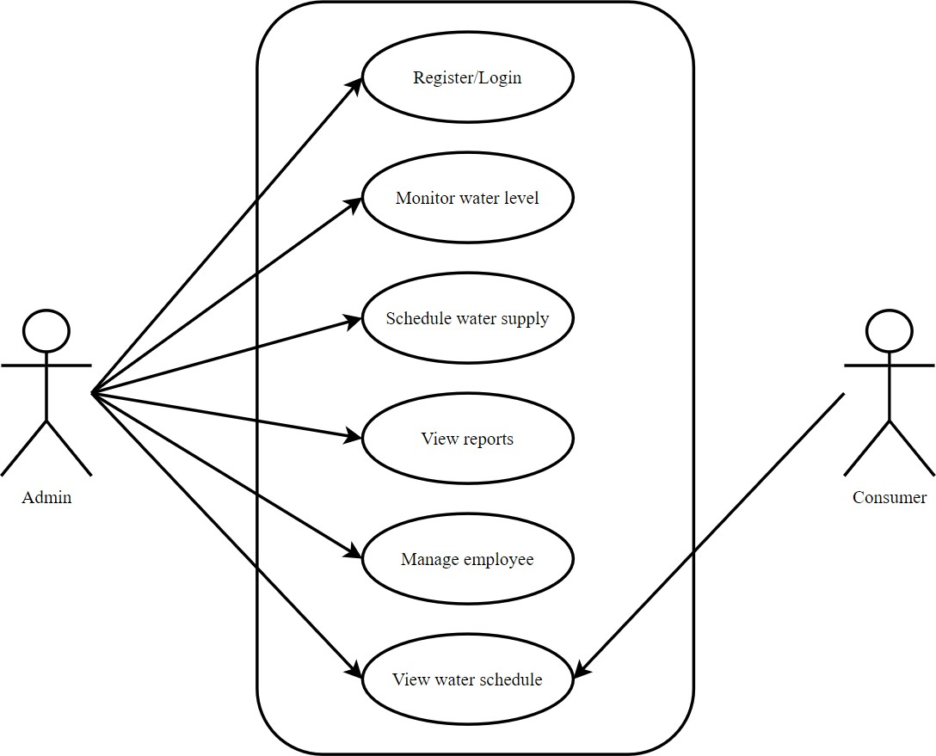

**Figure 4: Use Case Diagram of Water Distribution System**

## Expected Output

The expected outcome of this research project is the implementation of a system that ensures equitable water distribution based on real-time data, addressing the current disproportionate allocation caused by manual guesswork. By integrating this system, water management author- ities will gain insights into both the available water in tanks and the varying demands across different areas, which fluctuate based on factors like population density. This data-driven ap- proach will allow for the fair distribution of limited water resources, mitigating shortages and ensuring that areas with greater need are prioritized while still maintaining equity. Ultimately, the system aims to minimize the deficit until new water sources can be developed.

### References

1. Gyanu Maskey, Chandra Lal Pandey, and Monika Giri. Water scarcity and excess: water insecurity in cities of nepal. *Water Supply*, 23(4):1544–1556, 2023.
2. Aaron O’Neill. Urban population share in nepal in 2023, 2023. Data retrieved from website preview.
3. Rajesh Kumar Rai, Kaustuv Raj Neupane, Roshan Man Bajracharya, Ngamindra Dahal, Suchita Shrestha, and Kamal Devkota. Economics of climate adaptive water management practices in nepal. *Heliyon*, 5(5), 2019.
4. SUSWA. Suswa - sustainable water and sanitation in nepal. Website, 2024. Accessed: September 8, 2024.
5. Jangbahadur Prasad Yadav, Krishna Pratap Sah, Kaji Ram Karki, Mukti Nath Jha, AK Mishra, et al. Dharan water supply system–alarming issues and future. *J. Adv. Res. Civ. Environ. Eng*, 10:1–11, 2023.